**Steps for testing the SmartFundManager functionality**:

The idea behind preparing this document is it will give you understanding of the flow of the functionality and will assist you while testing the functionality.

**Step 1**: Start the ganache and make a note of 10 accounts (accounts and private keys) which you get when you start ganache.

**Step 2**: Go to Metamask Extension in the Browser and click on Import account and paste one of your private key string. Now you can see your account in the Metamask

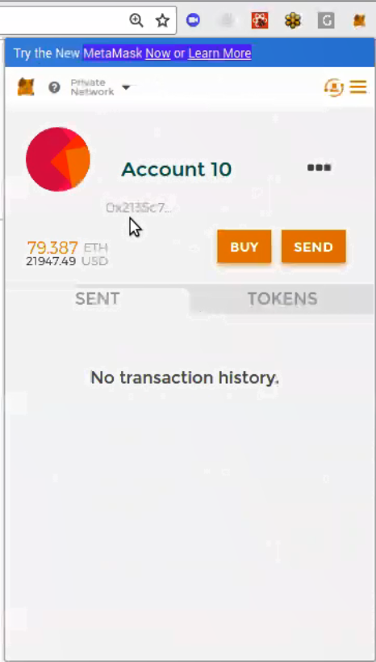

**Step 3**: Now in the investors tab enter any Ether value in the field **Investor Value(ether)** and click on submit as shown in the screen below

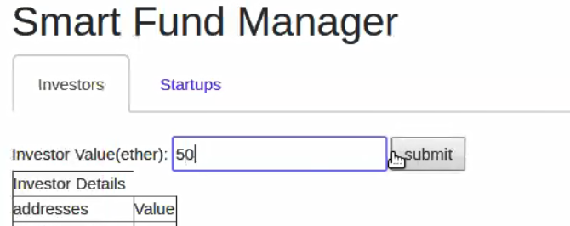

**Step 4**: Metamask screen will come up asking for Transaction Confirmation, and you click on Submit button as shown in the screen below

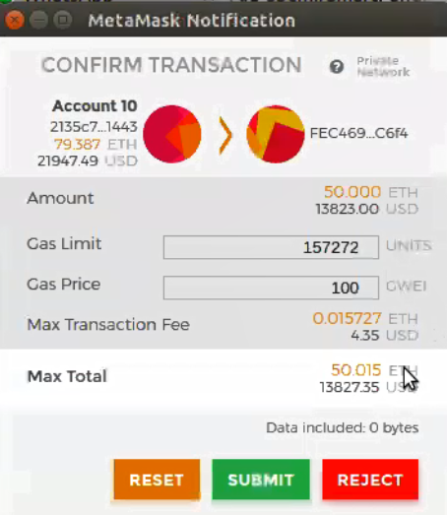

**Step 5**: Now pick another account (from the list of accounts which you noted when you started Ganache) repeat the Step 2 and Step 3 (with a different Ether Value) and Step 4. Now you can see both the addresses and their respective Ether investments.

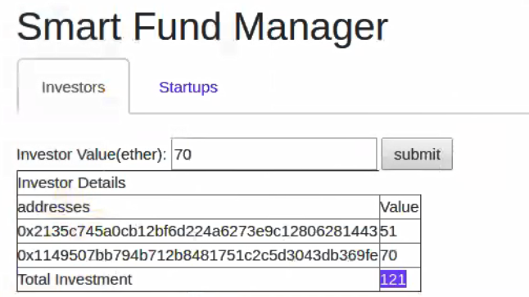

**Step 6**: Now click on the End Contribution Button. Metamask window will again appear asking for transaction confirmation, click on the Submit button. This basically ends the contribution from the Investors.

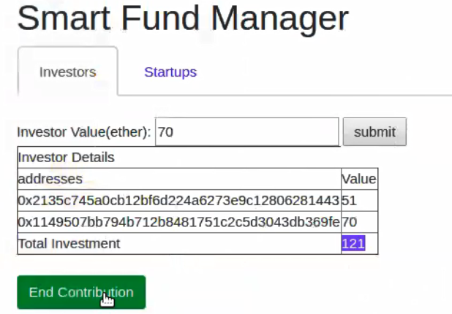

You will receive a Metamask confirmation as below



**Step 7**: Now comes the part of the Project proposals. Now go to the Metamask and import another account as shown below

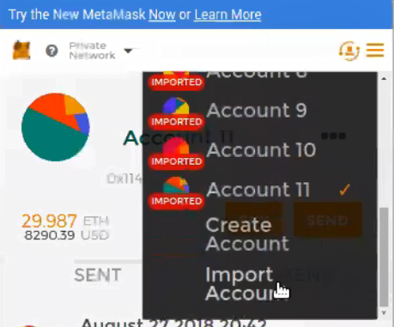

**Step 8**: Once account import is successful in the above step. Now the Startups/Innovators can submit their project proposals in the field Project Value and click on the Submit Project button as shown below

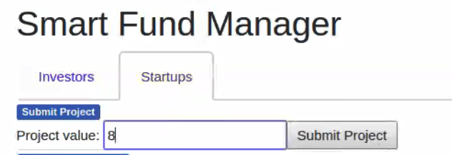

**Step 9**: Once the step above is successful, you can see Project Address along with Project value appears in the screen. You can also notice that Approve and Reject buttons got enabled

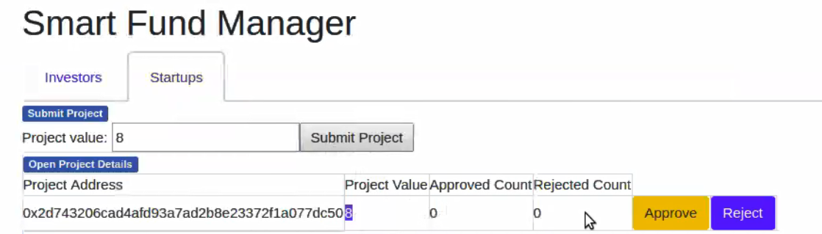

**Step 10**: Now if you click on the Approve button, you can see the approved count increased by 1 as shown in the screen below

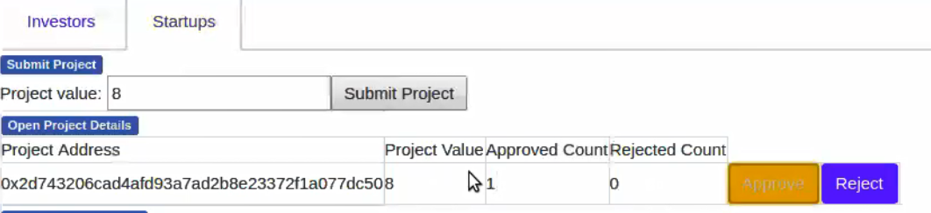

**Step 11**: If you click approve button one more time you can see the Approved Count increased by 1. **Please note I have removed conditions on Approve and Reject buttons to facilitate easy testing. Or else it will make the testing more cumbersome.**

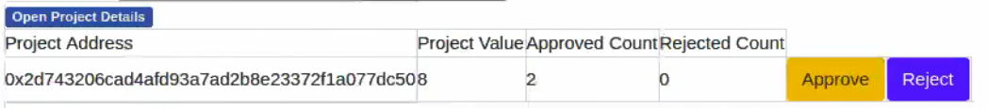

**Step 12**: Now you can try to withdraw some funds as shown in the screen below



Once you click on the Withdraw button you will be asked for the transaction confirmation as below. Click on the Submit button

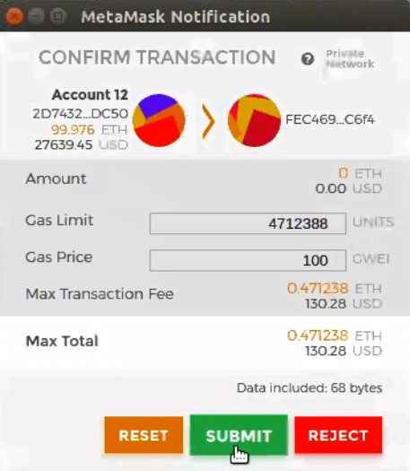

Once you click on the submit button you can now see the transaction is confirmed as below.

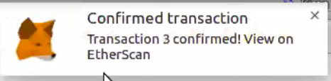

Happy Testing 😊